**SportsTeamManager**

Website: <http://sportsteammanager.cloudapp.net/>

GitHub: <https://github.com/ruth-mcelroy/SportsManager>

**Screenprints**

HomePage

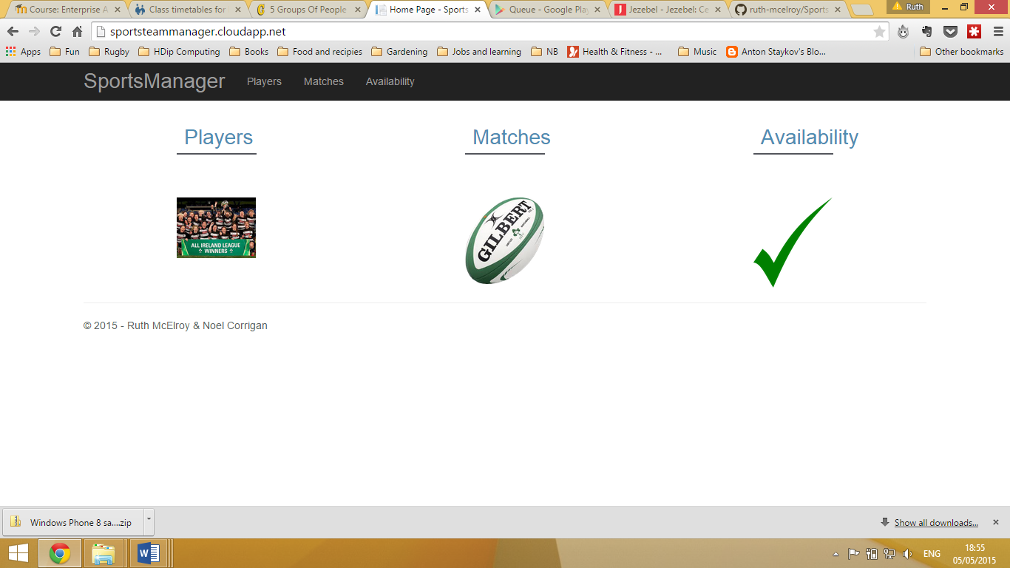

All Players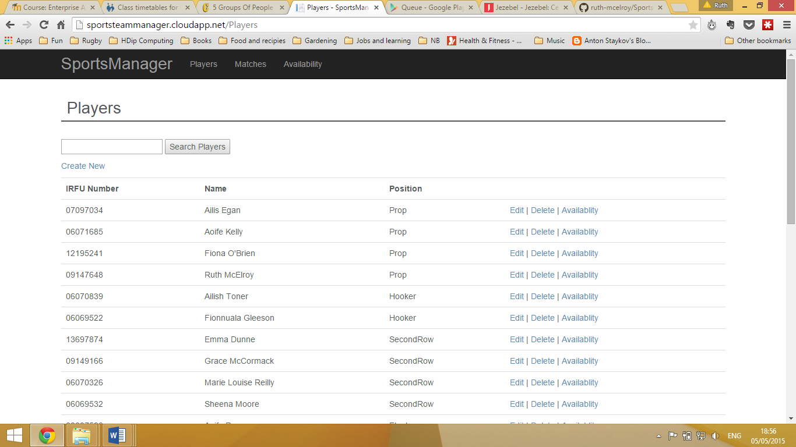

Search by position

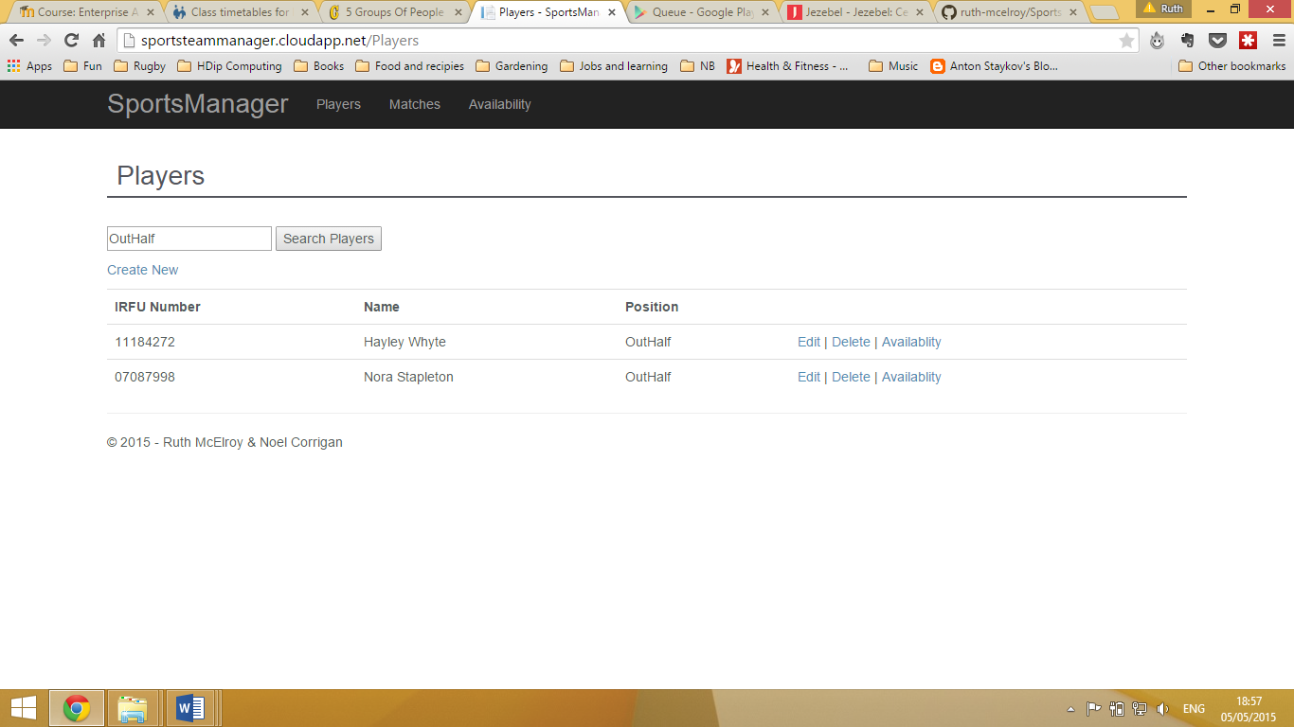

All Matches

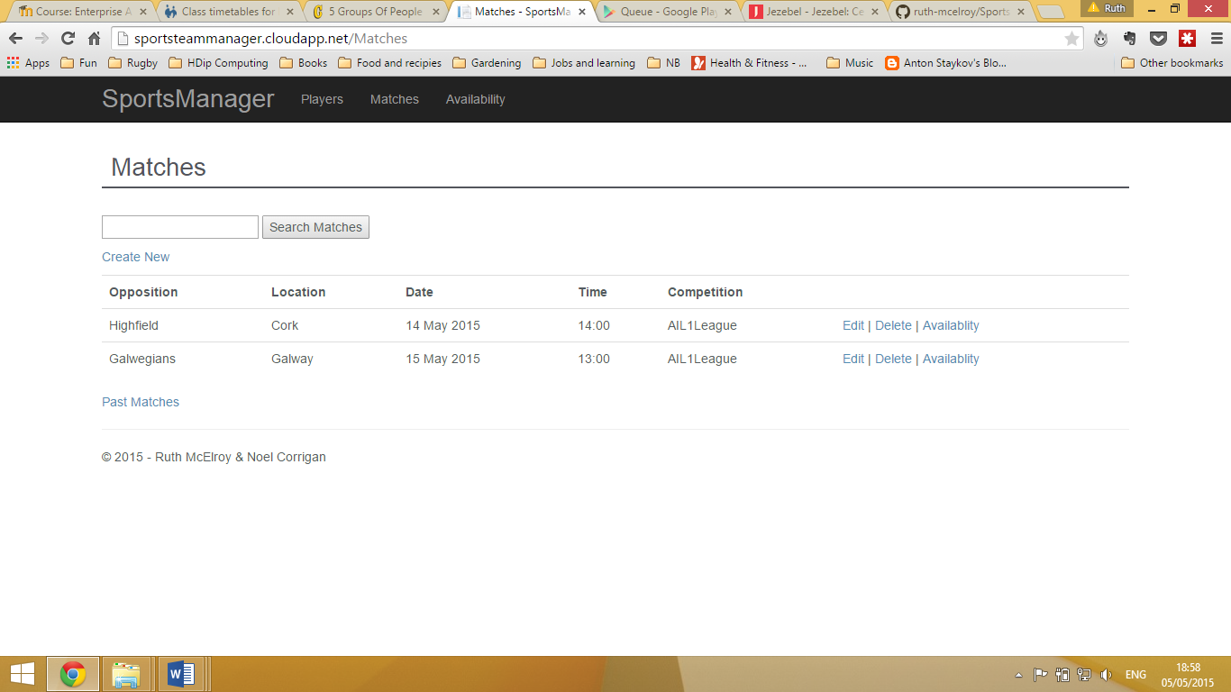

Search availability by match

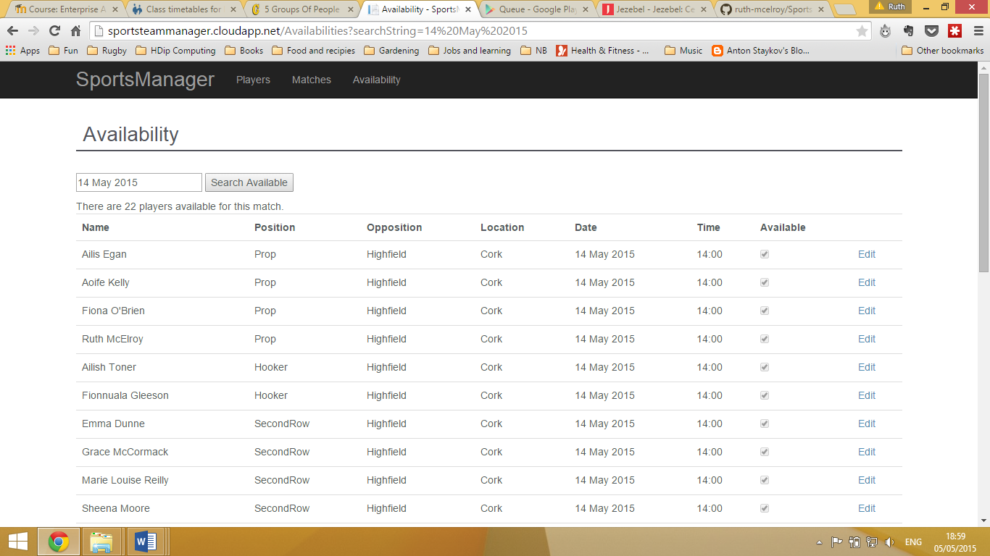

Search availabilities by player

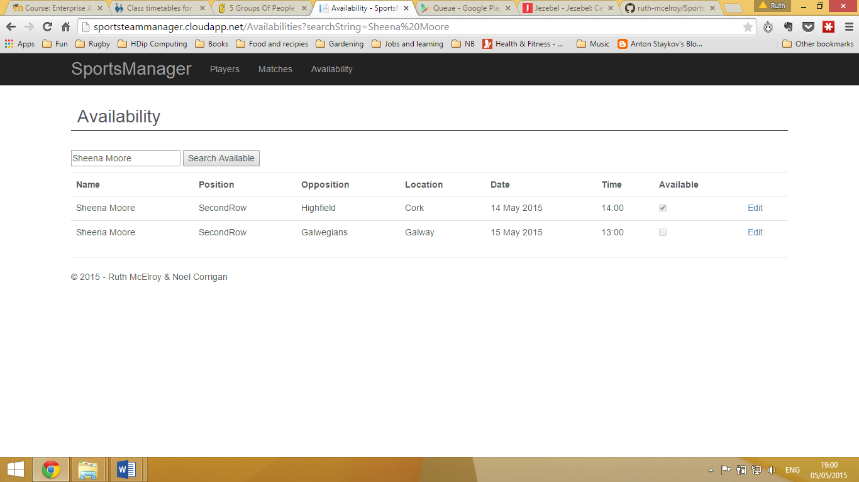

**URI Addressing Scheme**

1. Get availabilities by Irfu number

http://sportsteammanager.cloudapp.net/api/availability/{Irfu}

Example <http://sportsteammanager.cloudapp.net/api/availability/06071685>

2)Post Available with availability id.

[http://sportsteammanager.cloudapp.net/api/availability/{AvailabilityID}/{availableParam}](http://sportsteammanager.cloudapp.net/api/availability/%7bAvailabilityID%7d/%7bavailableParam%7d)

Example <http://sportsteammanager.cloudapp.net/api/availability/23/true>

Database



Code Metrics

